Oyster Task Force Meeting
Tuesday, June 6, 2023, 1:00pm
LDWF Headquarters
2000 Quail Drive
Baton Rouge, LA 70898

I. Pledge of Allegiance
II. Roll call and introduction of guests
Voting Members Present:
Jakov Jurisic
Mitch Jurisich
Brad Robin
Sam Slavich
Peter Vujnovich
Willie Daisy
Steve Pollock

Voting Members Absent:
Shane Bagala
Tracy Collins
Dan Coulon
Brandon DeBarge
Brandt Lafrance
Al Sunseri
Matthew Slavich

Non-Voting Members Present:
Robert Caballero
Edward Skena
Sarah Roy
Isabel Englehart in for Harry Vorhoff
Brian Lezina

Non-Voting Members Absent:

III. Brad Robin motioned to approve the May 9, 2023 meeting minutes, 2nd by Steve Pollock. Motion carries.

Brad Robin motioned to amend the June 6, 2023 meeting agenda by adding item A-1. To Hear an Update on Fisheries Disaster Funding under New Business, 2nd by Steve Pollock. Motion carries.

Brad Robin motioned to approve the June 6, 2023 meeting agenda as amended, 2nd by Willie Daisy. Motion carries.

IV. Treasury Report:
Remaining Fund Balance- $624,107
Remaining Budget Balance- $8,114
Tag sales for the month of May- 813,600

Brad Robin motioned to approve the treasury report as presented, 2nd by Steve Pollock. Motion carries.

V. Committee Reports:
A. Public-Private Oyster Seed Grounds Committee Report- no report
B. Enforcement Report-

May 2nd- May 31st

Region 4 (Iberia)
2-56:305 A-Take/Poss. Commercial fish w/o Commercial License
1-40:4 A- Violate Sanitation code (1 Log Book)
1-56:430 B(1)-Harvest oysters from unmarked lease
Seizures:
3 Sacks

Region 5 (Calcasieu and Cameron)
None

Region 6: (Terrebonne, Lafourche, Grand Isle, St. Mary)
Terrebonne
5- 56:424A- Unlawfully take oysters from state water bottoms
Seizures:
39 Sacks

St. Mary
4- 56:424E1-Take oysters from unapproved area(polluted)
Seizures:
33 Sacks

Region 8: (Jefferson, Plaquemines, St. Bernard, Orleans)
St. Bernard
1-RS 40:4A – Violate Sanitation code (1 Refrigeration)
Seizures:
21 Mini Sacks seized

Plaquemines
1-RS 40:4A – Violate Sanitation code (1 Refrigeration)
Seizures:
33 Sacks

C. Legislative Committee Report- no report
D. Legal Committee Report- no report
E. Research Report- no report
F. Coastal Restoration Committee Report- no report
G. Marketing Committee Report- Anna Koehl provided a marketing update from BMF- will be taping WWLTV video production with Brad Robin and some other oyster industry members and will add to the website and social to share

H. Health Committee Report- Mike Vidrine with LDH provided a brief update- 4 illnesses reported since the last meeting, all in the vibrio family in Alabama, Florida, and Louisiana do not have exact locations on these illnesses as of yet. The OTF held a Health Committee meeting prior to the full task force meeting and discussed retagging from white to green if mechanical failure or other emergency should occur- there will be strict regulations on this change, currently working on solutions, LDH will plan to report on the progress of this at the next meeting, LDH would need a legal opinion on this on whether it would take legislation or a rule change

I. Aquaculture Committee Report- no report
J. Joint Task Force Working Group Report- no report

VI. New Business
- Patrick provided an update on 2019 flood disaster funding, was approved by NOAA 2 ½ years ago, was told would have the money in house by May 2023 ,will probably be the end of June before money is received in house, hung up at NOAA legal, issues with match requirement proposed for industry members on some grants, because the State was not required to put any state match up for the grant there was some concern, from a legal standpoint, about requiring a match from a private individual, some other states have received their funding, it’s a $58M grant, also applied for 2020 and 2021 fisheries disasters and are awaiting for NOAA put forth an economic impact analysis on these disasters and are waiting to hear back

- The Task Force heard an update on the Oyster Strategic Plan
Robert Caballero provided an update on the Oyster Strategic Plan
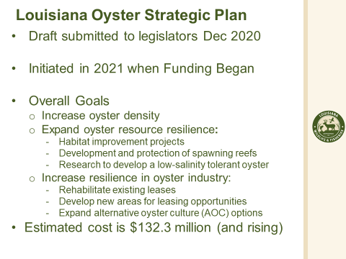
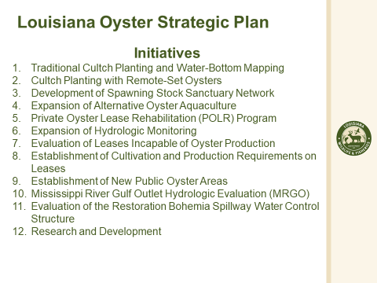
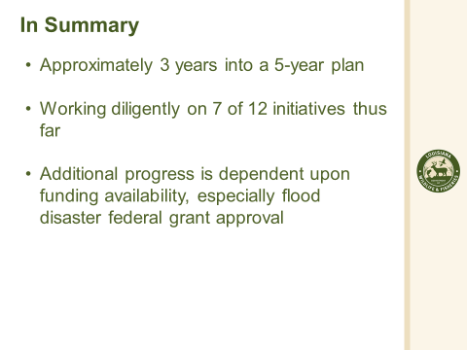
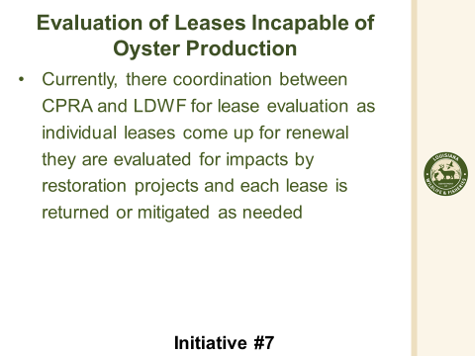
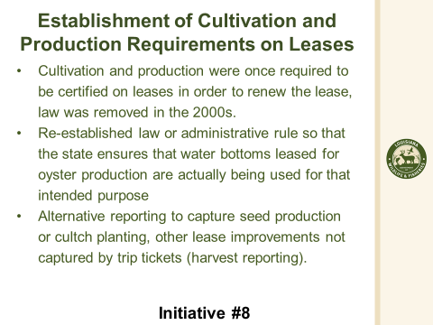
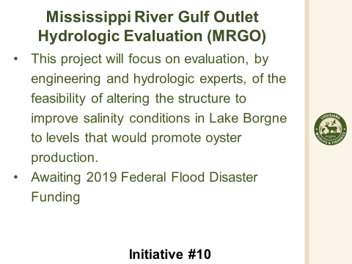
Mitch Jurisich stated that there is some concern with initiative 7, evaluation of leases incapable of oyster production, Concern that this is a way to evaluate leases that could be taken from the industry in the future. Patrick Banks stated that one of things LDWF is tasked with each year is providing CPRA with a list of what leases are up for the 15 year renewal, CPRA will then inform LDWF which leases they might need for coastal restoration projects, some of the discussions have been about should LDWF look further to see if there are leases that are up for renewal that are productive or not or even anticipated to be productive in the future. This initiative came about in case those discussions were to go any further. Unfortunately this has not gone any further because there is no funding to go out and evaluate these leases. The intent would not be to take productive areas from the industry, the intent would be if there are areas that are not productive, have not been productive and are not foreseen to be productive in the future then we may want to consider evaluating those leases for non-renewal at the 15 year spot. – Mitch Jurisich stated that he suggests this initiative stay unfunded, because leases that may be deemed unproductive now may be productive in the future
Brian Lezina stated that most of the ones that have been turned over are at the mouth of natural bodies of water and are land now and that’s all we have seen
Brad Robin stated that he believes this is another tool for CPRA to take leases away, Patrick Banks stated that places where the industry would move seed to is not the areas in question, need funds for this initiative
Sam Slavich asked who will conduct these evaluations to determine whether a lease is productive or not and what conflict resolution is in place if a fishermen disagrees with the assessment, Patrick Banks stated that the main goal would be for the assessments to be started in house at LDWF and if there was something that comes up that may need additional fieldwork or extensive background this may have to be contracted out to a private company
Mitch Jurisich stated that initiatives 7 and 8, believes these two things need to be put aside for now given the state of the industry; initiative 10 MS River Gulf Outlet Hydrologic Evaluation, Patrick Banks stated that the first thing they want to do is look into and evaluate all the hydrologic possibilities
Mitch Jurisich initiative 12- oyster tolerant to low salinity study, Patrick Banks stated that this was $5M/ year funded three years so far and in year 3, the hope is to find the money to fund it for year 4 and 5
Brad Robin stated asked how much has been expended on Spat Tech, Robert Caballero stated that the brood reefs on east side- $5M spent so far, would like to know the fastest ROI for the state on their money expended, would like to see an evaluation on what we are getting on return on these projects vs cultch planting, Robert Caballero stated that this analysis could take years to estimate value
John Zach Lea stated that he was involved with stimulating the request for this plan to be put out, need a salinity plan- where are we going to have the proper salinity to raise oysters in the state
Secretary Robert Shadoin introduced himself to the task force
Jakov Jurisic stated the task force will discuss walking the hill later in this meeting, in the past the OTF has walked the Hill and have not accomplished anything, wishing that this can change in the future
- Robert Caballero provided a presentation on the 2022/23 Public Seed Grounds Oyster Harvest and the 2023/24 oyster season timeline
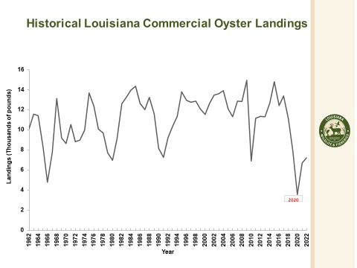
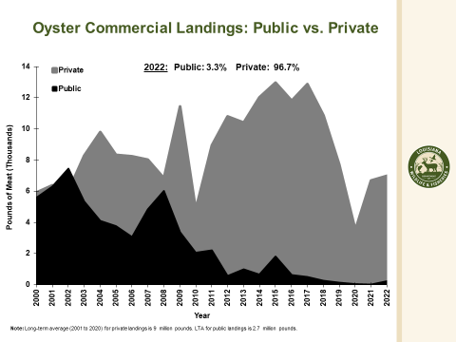
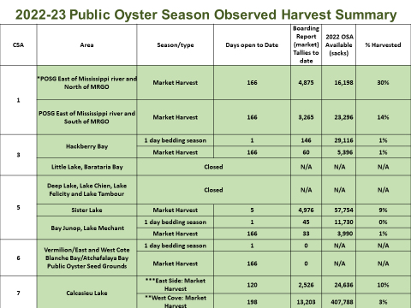
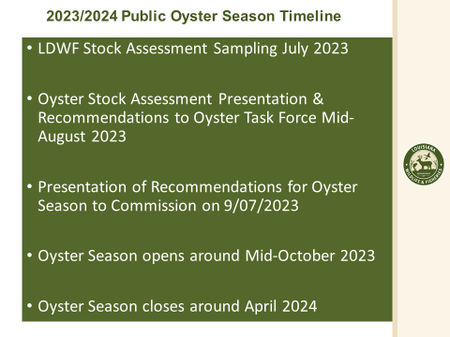
Jakov Jurisic asked why is LDWF reporting in lbs of oyster meat when this is not how we sell the product, Rob Caballero stated that this is how it is reported on trip tickets numbers and everything is reported to the Feds, Jakov Jurisic stated that this is incorrect, 80% of all oysters that come in are half shell product which is a lot more valuable that shucked product, this gives inaccurate picture to the public of what the oyster industry is worth/ what the actual value is
Patrick Banks stated that we may be able to put information from Jack Isaacs together that tracks where the oysters went whether that was to ½ shell or shucking and get that to the OTF to review further
D. Vince Cefalu provided a presentation on an LDWF E-reporting pilot program
Ereporting:
- New electronic reporting system to track commercially harvested seafood
- Currently a volunteer pilot program (oysters only) with the potential to replace paper trip tickets and the existing electronic reporting system for all seafood
- Goal is to increase the availability, quality, and accuracy of real time data
- New system will allow commercial fisherman/dealer to easily record and monitor their records.
- May provide an opportunity to use app to complete LDH Time-Temperature Log Sheet information.
How it works:
- Commercial fishers and dealers participating in the program must download the Ereporting app on their mobile device and register an account.
- Commercial fishers will initiate the trip ticket and submit to the dealer via the app. Dealer then accesses the app and completes the transaction. Fisher then reviews and signs off completing the transaction.
- During the pilot program, participants still need to report using current trip ticket process.

Why Ereporting:
- Provides real time data to make better management decisions.
- Improved accuracy by limiting transcription and scanning errors associated with paper trip tickets.
- Dealers and fishers will have real-time access to their data and transaction histories.
- Allows LDWF to estimate all commercial resources harvested.
- Eliminates paper forms, postage and trips to the post office.
- Data is submitted with the push of a button on site.
- Potential to replace an aging electronic reporting system that is pc based.
Volunteers Needed:
- LDWF is seeking wholesale/retail dealers and associated fisherman to participate in the program.
- Those interested in participating in the pilot study or for more information, contact:
Vince Cefalu
vcefalu@wlf.la.gov
225-765-2394

Jakov Jurisic asked about reporting that will be due by 9pm each night, what if there is no phone service and not scheduled to come in the next day, Vince Cefalu stated that will this is set to be sent when service is available

Mrs. Naquin asked if the option would be available to use either or the phone or the app

Buddy Pausina suggested having a feature that says delivered when messages are received

- Jack Isaacs provided an update on the Oyster Lease Damage Evaluation Board (OLDEB)
Jack Isaacs stated that at the March/ April OTF meeting he was asked to come up with a per sack harvesting cost for private oyster leases to be used to apply to the OLDEB’s assessment if there is some type of project that would cut across a lease and damage it, these leases are entitled to compensation; So what the damage evaluation board does is they go out, and somehow count the amount of oysters on the lease there, and they apply the estimate of their revenue, minus the cost of harvesting the oysters on that reef
Cost per Sack Estimator
SACKS per TRIP | 47.76
FUEL PRICE per GALLON | $5.00
HOURS per DAY | 6.00
CREW COST per DAY | $200.00
Crew per Hour | $33.33
CAPTAIN PAY per DAY | $350.00
Capt per Hour | $58.33
LENGTH of VESSEL (feet) | 45
HARVESTING COST per SACK
$13.48

Jack Isaacs stated that he would like to have Dr. Miriam look at the figures when she comes back and then we can provide this to the OLDEB, will come back to the next meeting with more information so the task force can make a final decision/ recommendation
John Zach Lea suggested looking at how much revenue is lost instead of looking at costs
- The task force heard a legislative update
HB438 passed the House and the Senate and is awaiting the Governor’s signature, Senate side tweaked it a small amount, also have the CRCL tax incentive bill for restaurants which provides up to $2000 tax break for restaurants that recycle their oysters/ return them to the water
Patrick Banks stated that the Funds Bills have been somewhat finalized late last week and moving through on final passage this week, there are a few items directly related to oysters they have to do with directing the department with some monies to implements certain elements of the oyster strategic plan
- The task force considered funding to travel to Washington, D.C. to Walk the Hill and attend 2024 LA Alive Event
Brad Robin stated that he would be in favor of getting tickets to LA Alive and/or hosting a booth
Jakov Jurisic stated that he thinks walking the hill is a waste of time and attending the LA Alive event is the same thing
The task force plans to continue discussion on this item and considering funding at their next meeting once that have more information
- Jakov Jurisic led discussion on printing copies of administrative code
Interested in getting copies of Title 49 MS, Title 56, Title 51, Title 75 TX, annual updated version that come out every year
VII. Public Comment
Rusty Gaude thanked Brad Robin and Jakov Jurisic for coming to the state of the coast and illuminating the issues
John Zach Lea announced planning a large oyster farm in western part, south of Houma
George Ricks announced that on Saturday from 9am-1pm seafood market at Delacroix fishing peer
VIII. Next meeting set for Tuesday, August 29, 2023 for 1pm at the New Orleans Lakefront Airport.
IX. Jakov Jurisic motioned to adjourn the meeting, 2nd by Brad Robin. Motion carries.

